Insert your name, centre number and candidate number into the header above.
Save this evidence document as evidence_ followed by your centre number_ candidate number. For example: evidence_ zz999_9999
Screenshots or program listings must be copied into appropriate cells in the following tables.
Examiners must be able to read the contents including any screenshots without the use of a magnifying glass. Answers that are not readable or missing will not be awarded any marks.
Save this evidence document at regular intervals, for example, every 10 minutes.
Question 1
Part 1(a)
# Class node:
class Node:
def __init__(self, data, nextNode: int):
self.data = data
self.nextNode = nextNode

Part 1(b)
# Declarations:
startPointer = 0
emptyList = 5
linkedList = [Node for i in range(10)]

Part 1(c)(i)
def outputNodes(linkedList, startPointer: int):
while linkedList[startPointer].nextNode != -1:
print(linkedList[startPointer].data)
startPointer = linkedList[startPointer].nextNode

if linkedList[startPointer].nextNode == -1:
return linkedList[startPointer].data

Part 1(c)(ii)
# Main
outputNodes(linkedList, startPointer)

Part 1(d)(i)
def addNode(linkedList: list, startPointer: int, emptyList: int):
data = int(input('Input the data to be stored: '))
currentPointer = startPointer

# If no nodes in linkedlist;
if startPointer == -1:
linkedList[0] = Node(data, 1)
startPointer = 0
emptyList = 1
return True

# Return if no free spaces
if emptyList == -1 or linkedList[emptyList].data != 0:
return False

# Find next free space
while linkedList[currentPointer].data != 0:
currentPointer += 1

if linkedList[currentPointer].data == 0:
emptyList = currentPointer + 1

while linkedList[emptyList].data != 0:
emptyList += 1

linkedList[currentPointer] = Node(data, emptyList)
return True

Part 1(d)(ii)
# Main
outputNodes(linkedList, startPointer)

result = addNode(linkedList, startPointer, emptyList)
if result == True:
print('Node added to the linkedList.')
else:
print('Node was not added LLLLLLLLLLLLLL')

outputNodes(linkedList, startPointer)

Part 1(d)(iii)
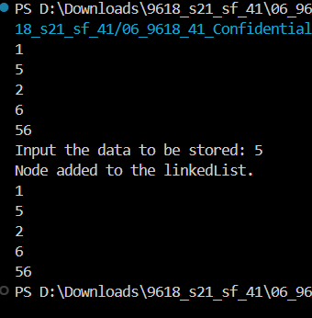

Question 2
Part 2(a)
# Main
arrayData = [int for i in range(10)]
arrayData = [10, 5, 6, 7, 1, 12, 13, 15, 21, 8]

Part 2(b)(i)
def linearSearch(search: int):
found = False
for i in range(len(arrayData)):
if arrayData[i] == search:
found = True
i += 1

if found == True: return True
else: return False

Part 2(b)(ii)
if linearSearch(int(input('Input a value to search for: '))) == True: print('Value was found')
else: print('Value was not found')

Part 2(b)(iii)
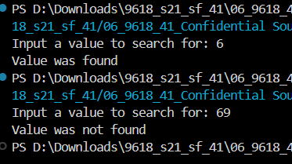

Part 2(c)
def bubbleSort(theArray):
temp: int = 0
arrayLen = len(theArray)

for x in range(0, arrayLen):
insideLen = arrayLen - 1

for y in range(0, insideLen):
if theArray[y] < theArray[y + 1]:
temp = theArray[y]
theArray[y] = theArray[y + 1]
theArray[y + 1] = temp

Question 3
Part 3(a)
class TreasureChest():
def __init__(self, question, answer, points):
self.__question = question
self.__answer = answer
self.__points = points

Part 3(b)
def readData():
global arrayTreasure

try:
with open('./TreasureChestData.txt', 'tr') as file:
lines = 0
# Read the amount of lines in file
for line in file:
lines += 1
# Reset back to 0
file.seek(0)
lines = lines // 3

arrayTreasure = []
for i in range(lines):
q = file.readline().strip('\n')
a = int(file.readline().strip('\n'))
p = int(file.readline().strip('\n'))
arrayTreasure.append(TreasureChest(q, a, p))

except:
raise FileNotFoundError('The file is not available!!1!1!')

Part 3(c)(i)
def getQuestion(self):
return self.__question # this is within the class

Part 3(c)(ii)
def checkAnswer(self, answer):
if self.__answer == answer:
return True
else: return False # this is within the class

Part 3(c)(iii)
def getPoints(self, attempts):
if attempts == 1: return self.__points
elif attempts == 2: return self.__points // 2
elif attempts == 3 or attempts == 4: return self.__points // 4
else: return 0 # thisis within the class

Part 3(c)(iv)
# Main
readData()
attempts = 1
qNum = int(input('Enter a value between 1 and 5: '))
qNum -= 1

print(arrayTreasure[qNum].getQuestion())
while arrayTreasure[qNum].checkAnswer(int(input('Enter your answer:'))) != True:
attempts += 1

print(attempts)
print(arrayTreasure[qNum].getPoints(attempts))

Part 3(c)(v)
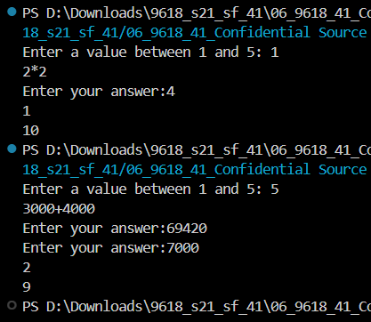

File directory:
root
- src
-- q1.py
-- q2.py
--q3.py
- evidence.doc
-TreasureChestData.txt

